1. **Comparison of Donation Characteristics Between OLP Master's and In-Person Master's Alumni**

1.

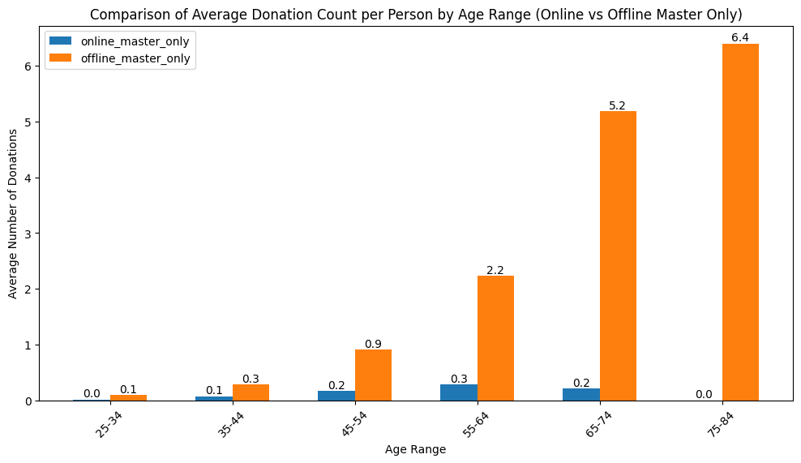

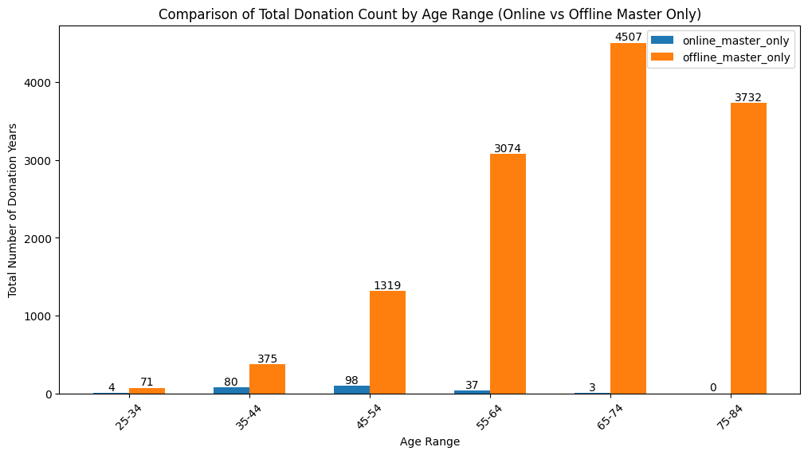

Key takeaway:

Overall, alumni who took online courses donated significantly fewer times than those who attended in-person courses. Among online course alumni, those around 60 years old had the highest average donation frequency. This may be because online programs were introduced relatively recently, meaning alumni over 70 did not have the opportunity to participate in OLP when they were younger. We may consider targeting alumni aged 55–65 for donation recommendations, as they are more likely to contribute.

2.

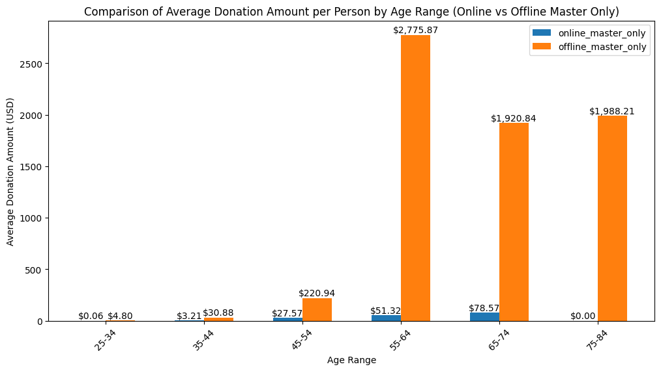

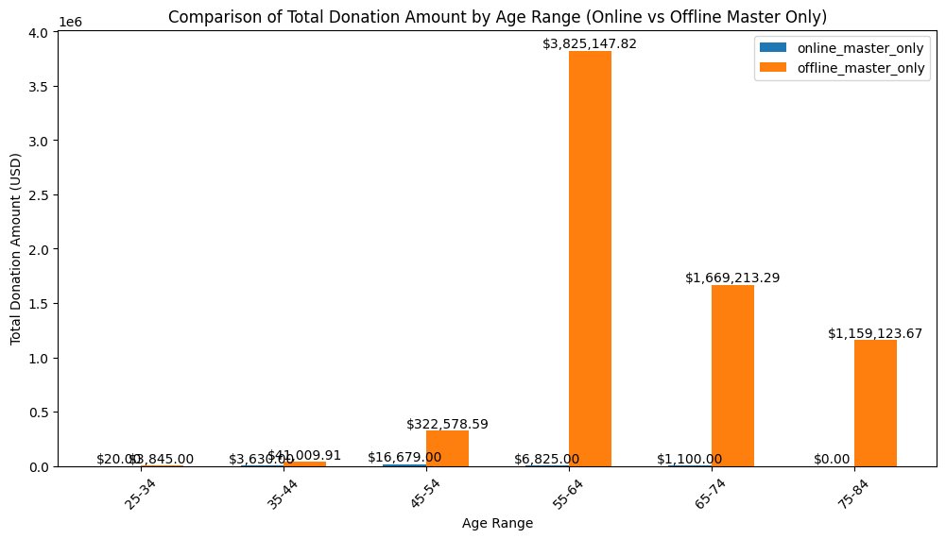

Key takeaway:

Alumni around 60 years old who attended in-person programs are the main contributors in terms of donations. Among online program alumni, those around 70 years old have the highest average donation amount per person. We may consider targeting in-person master’s program alumni around 60 and online master’s program alumni around 70 for donation reminders.

1. **Analysis of "Propensity to Give" Differences Between the Lapsed Group and Other Alumni**

1.

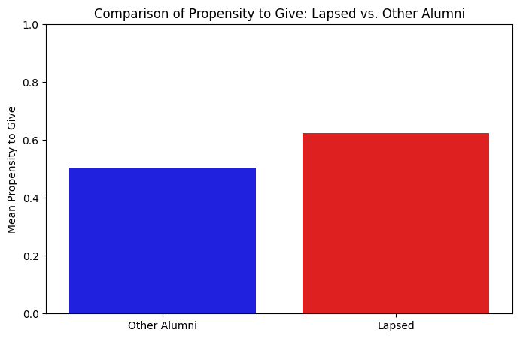

Compared to other alumni, the lapsed group has a slightly higher ‘propensity to give’, approximately 0.07 higher. This suggests that alumni in the lapsed group have relatively greater donation potential.

2.

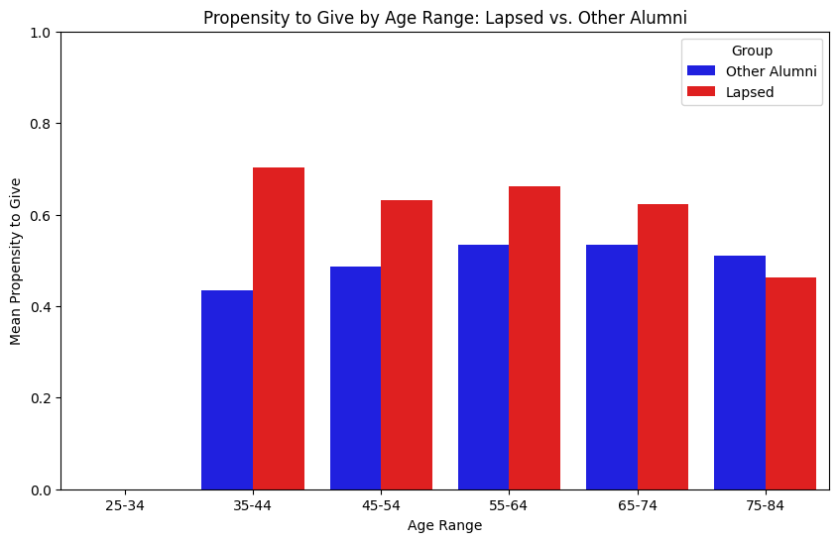

Key takeaway:

Among other alumni, those aged 60–70 have the highest propensity to give. However, in the lapsed group, alumni around 40 years old show a significantly higher propensity to give, followed by those around 60. Therefore, for the lapsed group, we may prioritize targeting alumni around 40 and 60 years old.

1. **Analysis of "Trust Association" Differences Between the Lapsed Group and Other Alumni**

1.

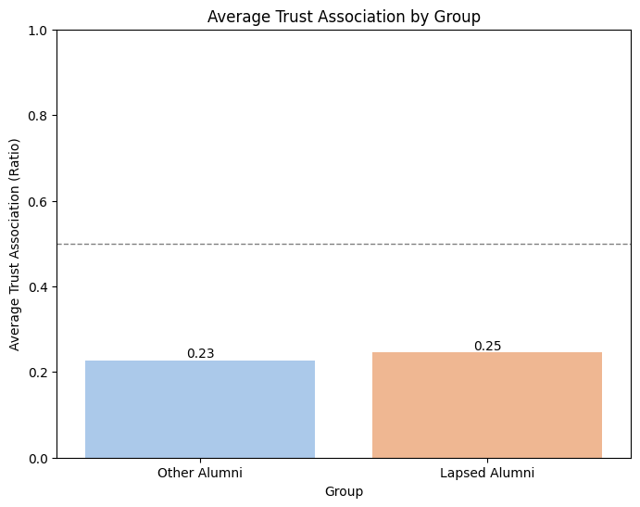

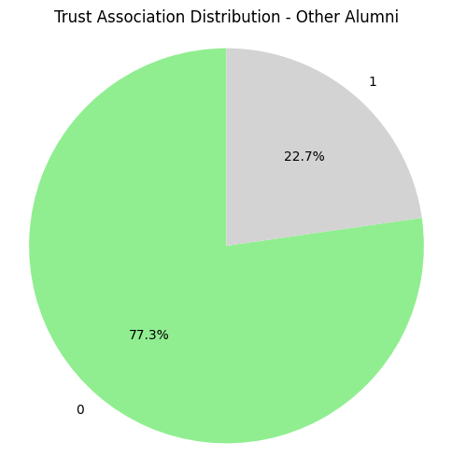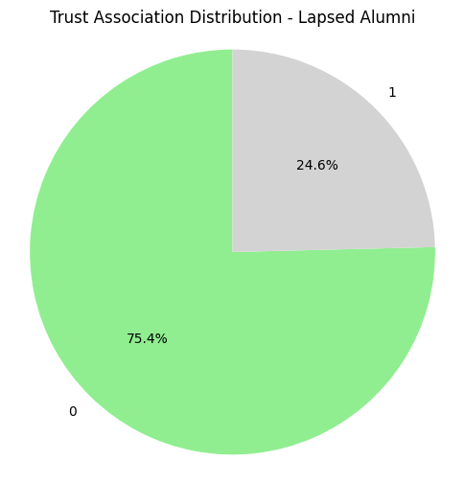

2.

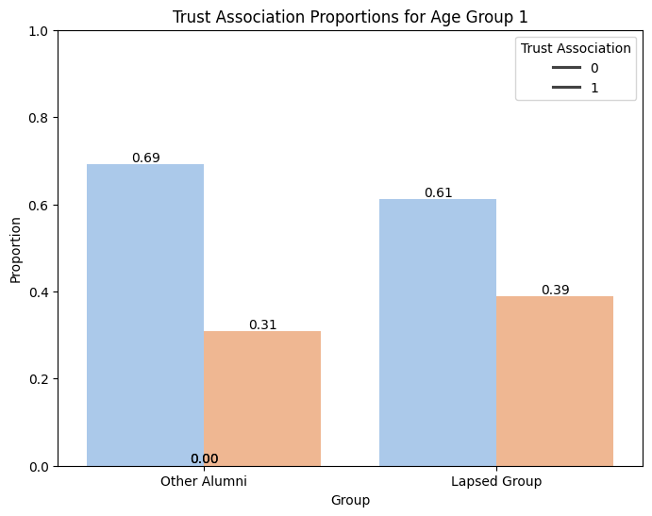

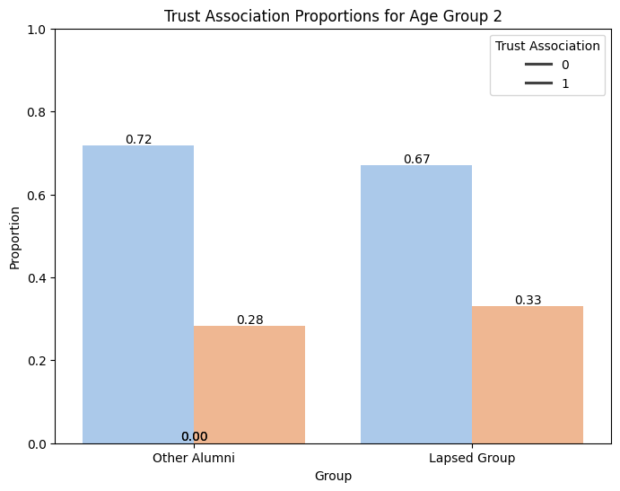

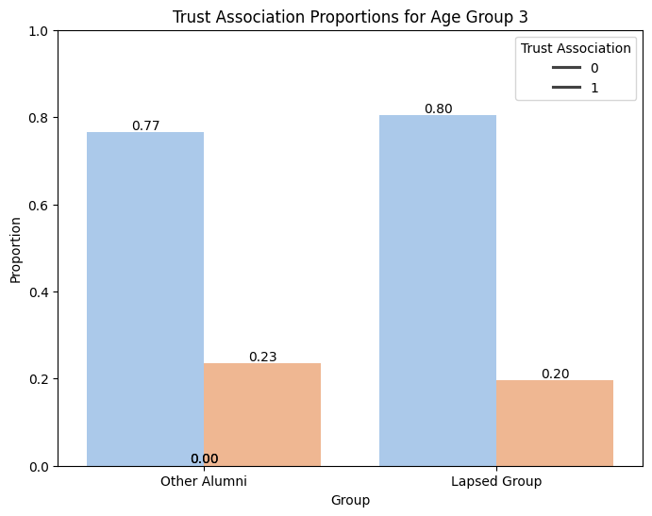

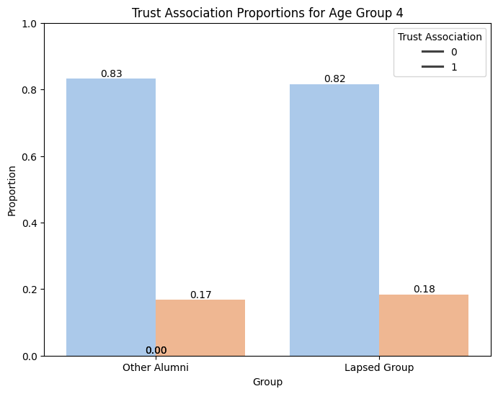

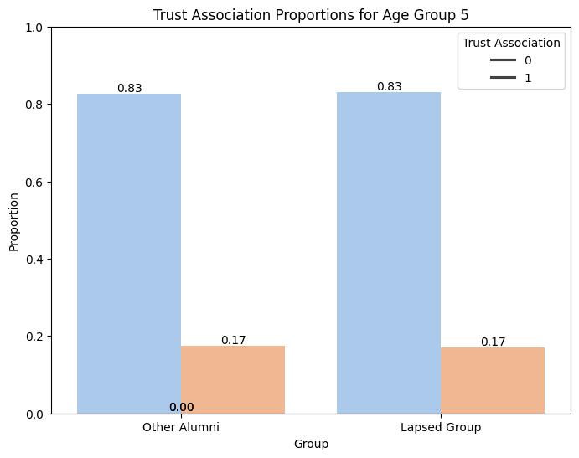

Group 6 consists of alumni around 30 years old. We found no Trust Associate data for this group, which may be due to their younger age.

Key takeaway:

We can see that in the 60s and 70s age groups, the proportion of the lapsed group is significantly higher. However, in the younger age groups, the difference between the two groups is not as noticeable, and the proportion of the lapsed group may even be smaller. This suggests that older age groups may have greater donation potential.